PERSONAL INFORMATION | Vasil Negentsov
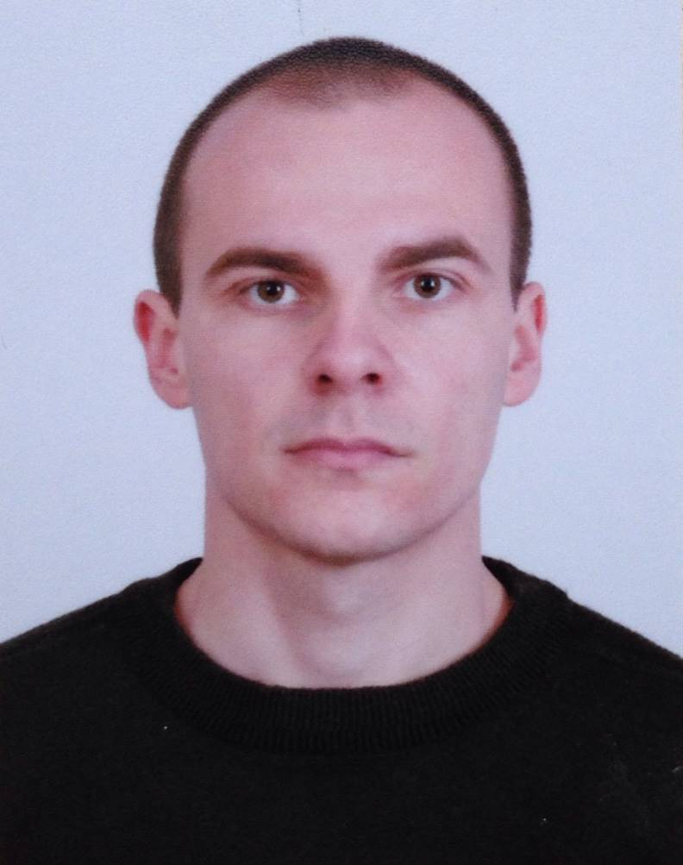 |   №5 3004, 1324 Sofia (Bulgaria)

+359883444941

negentsov@gmail.com

WORK EXPERIENCE
Feb 2016 – By now | Electrical Power Dispatcher
 | "CEZ Distribution Bulgaria", Sofia (Bulgaria)
• Use control software "SCADA" to control and monitor power grid.
• Control the distribution grid, keeping track of the status of circuits and connections.
• ​Respond to emergencies, such as transformer or transmission line failures, and route current around affected areas.
•​ Direct personnel orders to control room operators, or emergency teams to switch distribution equipment.
•​ Execute switching orders. Isolate work area, referring to drawings of power systems and emergency team.
•​ Record and compile operational data, using transmission system maps and control room operators.

Nov 2015 – Jan 2016 | Test Engineer
Nov 2015 – Jan 2016 | "Elia-Control body", Sofia (Bulgaria)
Nov 2015 – Jan 2016 | •​ Control of High voltage Equipment and Secondary commutation​​  • Issuance of protocols according to regulatory requirements. BG Regulation № ​16-116,№ 3​, НИЕМЕС 1995, Technical Specifications  •​ ISO/IEC 17020:2012​

Mar 2013 – Jul 2015 | Engineer Electrical and Mechanical Equipment
Mar 2013 – Jul 2015 | ABB Bulgaria, Sevlievo (Bulgaria)
Mar 2013 – Jul 2015 | • ​​Inspection of the new project documentations before their entering in the production line.​  • ​Coordination with the production line for the wire loops (group of cable installation) and their routes. Determination the wire loops according the takt on the line.​  • ​Creating the programming code (macros in Excel) with the aid of which will be created​ the lengths of the wires, their crimps and sorting according to the specific criteria.​  • Preparing all documentation related to the production process ​about make the cable installation with the Komax machine.​​​  • Topical revisions into the electrical diagram and their agreement with the responsible engineer of the project in Germany.​.  • Continuously improvement about the process for creation of the „Komax“ files.​

Oct 2011 – Feb 2013 | Tester LCC (Local Control Cubicle)
Oct 2011 – Feb 2013 | ABB Bulgaria, Sevlievo (Bulgaria)
Oct 2011 – Feb 2013 | •​ ​Testing and check for properly working of Control Cubicle for Switchgеаr​ and MECB.  • Check for proper operation of the electrical interlocking and elements on the control board.  •​ Setup value of the multi-meter device and Power factor controller for MECB  • Issuance of testing protocols.​  •​ EN 61439

EDUCATION AND TRAINING

Sep 2007 – Nov 2013 | Bachelor and Master degree - Power Engineering and Electrical Equipment
Sep 2007 – Nov 2013 | Technical University of Gabrovo, Gabrovo (Bulgaria)

Sep 2003–May 2007 | Secondary Education - Programmer / Operator for CNC Machines
Sep 2003–May 2007 | Professional Technical School, Gabrovo (Bulgaria)

PERSONAL SKILLS

Mother tongue(s) | Bulgarian
Other language(s) | UNDERSTANDING |  | SPEAKING |  | WRITING
Other language(s) | Listening | Reading | Spoken interaction | Spoken production
English | B1 | B1 | B1 | B1 | B1

Communication skills | - Good communication skills gained through teamwork.

Organisational / managerial skills | - Good organization skills gained from my previous job​ in ABB

Digital competence | Microsoft Excel, Word, VBA for Excel, AutoCAD​​, E3 series-Redliner

Driving licence | B

ADDITIONAL INFORMATION

Rules for safety at work in the electrical systems - Fourth group​​

